Zero Tolerance Initiative Overview

Slide 1

Zero Tolerance Initiative overview

Slide 2

When we talk about abuse, neglect and violence
Some of the things we talk about might make you feel uncomfortable. It’s OK to have a break if you need to. Think about who you can talk to if you extra support.

Beyond Blue:
1300 22 4636
Website

Lifeline:
13 11 14
Website

1800 Respect:
1800 737 732
1800 Respect website

Slide 3

The Zero Tolerance Framework

Understanding Abuse
- Promote and apply human rights
- Understand causes of abuse
- Recognise risk factors and signs of abuse

Practices and safeguards which can help prevent abuse
- Implement policy and practice that protect people’s rights
- Support empowerment of people with disability
- Create the right organisational cultures

Addressing risk for specific groups and service settings
- Targeted approaches for groups at increased risk of abuse
- Target service features and settings that increase risk
- Reducing and eliminating restrictive practices

Responding to abuse
- Early intervention and response
- Supporting the person
- Meet legal and organisational requirements

Analysis, Learning and Improvement
- Maintain and analyse records
- Continuous improvement
- Support initiatives to reduce abuse
Decorative images omitted.

Slide 4

‘Speaking up about safety’
In the 2014 report ‘Speaking Up About Safety’, people with disability said that they feel safe when service providers:
- Listen
- Respect people’s choices and decisions
- Involve people with disability in planning their services
- Make sure that staff can do their job properly
- Get to know people and treat them as an individual
- Support contact with services like police or advocacy
- Ensure respect for personal space and privacy
- Offer choice about who people live with
Speaking Up about Safety Summary and Full Report
Decorative image omitted.

Slide 5

Zero Tolerance Resources

Understanding abuse
- Human Rights and You: 30 minute eLearning program and guide
- Understanding Abuse: 40 minute eLearning program, set of eight films, workbook and guide for supervisors
- Empowerment Circle

Practices and safeguards which can help prevent abuse
- Practice advice: Safer Recruitment and Screening, Supervision and Safety
- Positive Cultures: set of eight films and guide

Addressing risk for specific groups and service settings
- Recognising Restrictive Practices: seven pairs of films and guide

Responding to abuse
- Responding to Abuse: set of eight films and guide

Analysis, Learning and Improvement
- Safeguarding for Boards guide
Decorative image omitted.

Slide 6

How to use the Zero Tolerance resources
- In board meetings
- As part of induction
- During ongoing staff training
- As part of supervision
- During staff meetings or team discussions
- In personal reflection
- With people with disability, families and carers
Decorative image omitted.

Slide 7

Abuse and neglect can be:

Deliberate
- perpetrators target people with disability
- people seek to harm or take advantage of others
- exploit vulnerability of systems and people
- cutting corners, rushing activities and supports.

Accidental
- prioritisation of routine over personal choice
- staff don’t realise their actions are abuse
- staff don’t understand the impact of their actions
- actions indirectly impact on someone else.

Systemic
- staff not trained or supervised properly
- staff don’t have the resources to do their job
- insufficient staff due to high sick leave / turnover
- people forced to live with others who pose a risk.
Decorative images omitted.

Slide 8

The Empowerment Circle
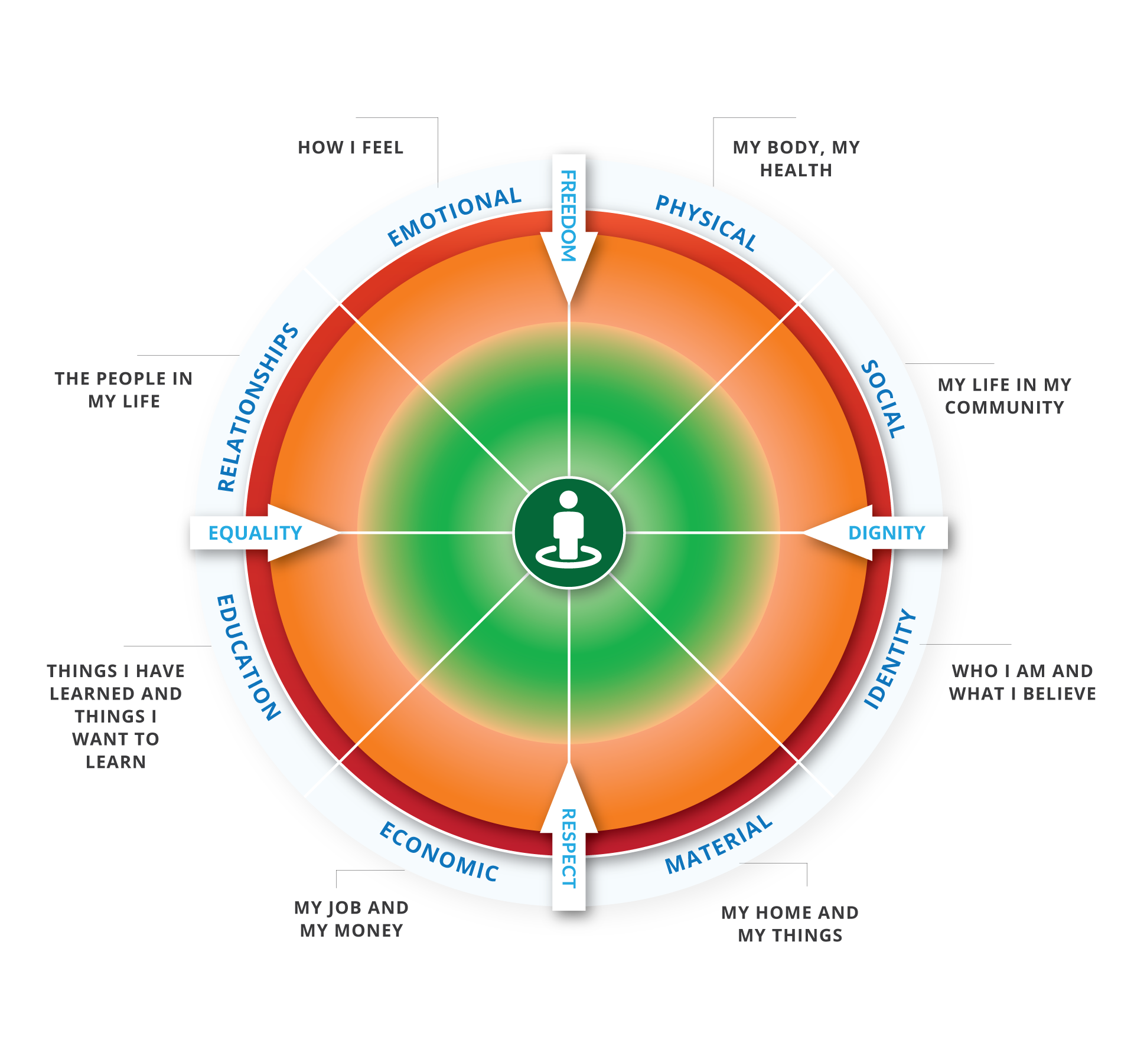
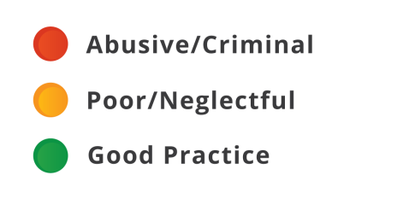

Slide 9

The Zero Tolerance Commitment
A commitment by organisations and people to speak up and take action on:
- anything that does not support a person’s rights
- anything that might make a person feel or be unsafe
- anything they could be doing better
Decorative image omitted.

Slide 10

Contact us
NDS Zero Tolerance Website
Mary Lou McPherson – email here.
Dave Relf – email here
Decorative image omitted.
End of document.

