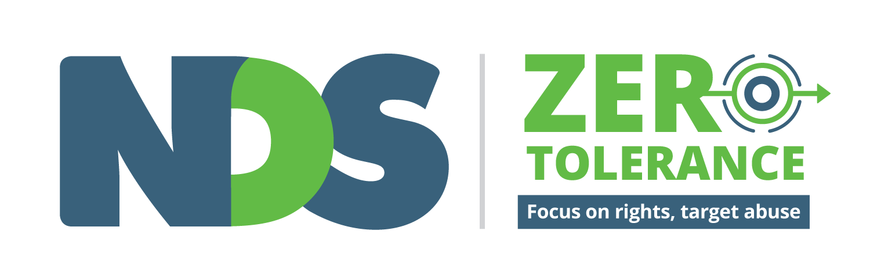

Speaking Up About Safety

Views of people with disability on personal safety

Summary Report – June 2014

Thank You

National Disability Services would like to thank the people from across Australia who shared their experiences and ideas about safety with us.

We also want to thank the eleven organisations who led the focus groups and Dr Sally Robinson from the Centre for Children and Young People of Southern Cross University for her support and expertise in this project.

Who is National Disability Services?
National Disability Services helps disability service providers and governments to provide better services for people with disability. National Disability Services is sometimes called NDS.

What is the Zero Tolerance?
Zero Tolerance means it is never OK for anyone to hurt you, steal things from you, do things to you that you don’t want them to or make you feel bad. If you do not feel safe you should be able to tell other people and get help if you need it.

NDS is working with disability service providers to do everything they can to make sure people with disability are safe and feel safe when they use their services. We have also been working with people with disability, advocacy organisations, commissioners, governments and universities to make disability services safer for people with disability. This work is called the Zero Tolerance Initiative.

Why did NDS want to talk to people with disability?
NDS thinks that people with a disability know best about what makes them feel safe. That’s why we asked people with disability about what being safe means to them and how services can help make people safer.

What did NDS want to know?
We wanted people to tell us:
- What things does your service provider do that make you feel like you matter?
- What things help you feel safe at home?
- What things make you feel safe when you are out in the community?
- What you would do if you didn’t feel safe? Is there someone you could tell?
- What things could your service provider do better to help you stay safe?
Where did people answer the questions?
NDS asked advocacy organisations and other experts to run meetings called focus groups. This is where a small group of people can come together and talk and share ideas. The organisations asked people to be part of a focus group and to talk about the questions on safety.

When did the focus groups happen?
The focus groups took place in March and April 2014. There were 11 focus groups in total. There was one in every state and territory. We also held extra focus groups for talking to:
- Women with disability
- Indigenous people with disability in remote communities
- People with disability who need communication support
The organisations that ran the focus groups and the focus group dates were:

- ACT, Advocacy for Inclusion, 17 March, 4 participants
- NSW, NSW CID, 14 March, 5 participants
- NT, Darwin Community Legal Service, 10 March, 6 participants
- QLD, Queenslanders with Disability Network, 6 March, 8 participants
- SA, Julia Farr Purple Orange, 7 March, 4 participants
- TAS, Speak Out, 12 March, 6 participants
- VIC, VALID, 25 March, 5 participants
- WA, PWDWA, 4 April, 5 participants
- Women’s Group, Women with Disability Victoria, 13 March, 7 participants
- Indigenous Group, NPY Women’s Council, 14 March, 6 participants
- Complex Communications Group, Scope Communication Resource Centre, 19 March, 3 participants
- Total of 58 participants

All together 58 people came to share their views. In Darwin and Alice Springs it was hard for people to get together, so people gave their answers to organisations separately one at a time.

Who went to the focus groups?
The focus groups were confidential. This means the organisations promised to not tell NDS or anyone else the names of the people in the focus groups.
People shared some details about themselves so we could make sure we were talking to people with disability with different backgrounds. We know that:

- Half of the people with disability were men and half were women
- There were people of all ages. Most people were between 35 and 55 years old
- There were people with physical disability and intellectual disability. Some people had more than one disability.
- Some people lived with their family, some lived on their own and some lived with other people
- Some people had jobs, some people went to day services, some people volunteered and some people had no services in the day time.
- All the people are using some kind of disability service at the moment.

What did people say?

Question 1: What things does your service provider do that make you feel like you and your decisions matter?
People at the focus groups told us they felt they mattered when service providers:
- listen to people with disabilities
- respect people’s choices and decisions
- involve people with disability in planning their services
- treat people as individuals
- make sure that staff can do their jobs properly
- give people real choice about things they can do
- show respect for privacy
- help people to do the things they need help with

Question 2 asked: What things help you feel safe or stay safe at home?
People at the focus groups told us things that help them feel safe at home are:
- family and friends - including living with family at home, calling friends and family on the telephone and people coming over to visit or stay over
- having a choice about the workers who supports you and what they do
- when support workers say and do the right things
- when support workers get to know you as a person and treat you as an individual
- when service providers help with things like keeping the house tidy and shopping
- being able to lock doors, leave lights on and have pets
- being able to contact other services like the police or advocacy
- support workers and other housemates respecting space and privacy
- having choice about who you live with
- support workers who understand this is your home, not their workplace

Question 3 asked: What things make you feel safe when you are out in the community?

People at the focus groups told us things that help them feel safe in the community are:

- being with friends, family and people you know
- being able to call friends and family if you need them
- good support workers who can help when you need help
- trying to stay away from dangerous people and situations
- preparing before you go out including charging batteries, planning transport and learning about places you might be going
- using the same taxi drivers and bus drivers so they get to know you
- being confident and feeling able to try new things
- mobile telephones and iPads to keep in touch
- contacting the Police if there are problems

Question 4: What would you do if you didn’t feel safe? Is there someone you could tell?

People at the focus groups that if they were feeling unsafe they would contact:

- the boss or manager of their support workers
- their support workers
- someone in their family
- friends
- the Police
- an advocacy organisation
- a specialist service like a sexual assault centre
- some people said they would use their mobile phone or computer to tell people because they might want to tell someone in secret

Question 5 asked: What things could your service provider do better to help you stay safe?

People at the focus groups said service providers should:

- ask people with disability their opinions and listen to their answers
- show respect for people with disability and their choices
- support people with disability to be involved in decisions about their lives
- give people information and training about rights, safety, advocacy and support services
- make sure support workers are the right people for the job
- train support workers about safety and rights for people with disability
- not change staff all the time so support workers get to know people
- show people how to complain or speak up when they feel unsafe
- help people with day to day things like keeping the home tidy and safe
- give people more choice about when they can do things, especially in accommodation
- understand the that people with disability are different in lots of ways, including
  - people who communicate in different ways
  - men and women with disability
  - people from different cultures and places
  - people who are parents
  - people who are gay or lesbian
- help people to use mainstream services like health and assault services when they need them

What will NDS do with these answers?
NDS wrote this report so that everyone can hear what people said about safety. We think what people said is very important and we have used what people told us to help us create training for service providers about how to make services safer for people with disability.
We still want people to read these answers and to talk about safety with their friends, families, advocacy groups and service providers. We think everyone can learn from what people said. Please share this report with people who you think might be interested to read it.
You can also call or write to us and tell us what you think about the report. Any other feedback you might like to share is also welcome. You can send an email to James Bannister at NDS. His email is james.bannister@NDS.org.au. You can also call James in Melbourne on (03) 8341 4316.

Someone is hurting me and making me feel unsafe now

If someone is hurting you (or someone you know) you should tell someone about it straight away. You can tell your friends, your family, an advocacy service, the police or someone you trust at your service provider so that they can find out what is happening and make it stop.
If you are in immediate danger please call “000” now.
If you need to talk to someone in private, you can call the National Disability Abuse and Neglect Hotline for free on 1800 880 052. People at the hotline can give you advice and information about services that can help you. They also have a website with more information on your rights and what you can do if you want to speak to someone: www.disabilityhotline.net.au

Where can I find out more information about the Zero Tolerance project?

For more information, tools and resources about Zero Tolerance visit the Zero Tolerance project page on the NDS website: https://www.nds.org.au/resources/zero-tolerance

