Recognising Restrictive Practices Workshop Zero Tolerance session

Slide 1

Recognising Restrictive Practices Workshop

Slide 2

Before we begin
- Some of the things we talk about might make you feel uncomfortable
- It’s OK to have a break if you need to
- Think about who you can talk to if you need extra support
- Lifeline: 13 11 14
- Beyond Blue: 1300 224 636

Slide 3

In this session
- A Human Rights based approach
- The NDS Zero Tolerance Initiative: An overview
- Quality of life
- The misuse of restrictive practices
- What the evidence tells us
- Practice Leadership & Reflective Practice

Slide 4

A Human Rights based approach
- Recognising an individual’s rights is paramount to the support provided.
- Reducing and eliminating the use of restrictive practices is consistent with the UNCRPD.
- Restrictive practices should only occur as a last resort, using the least restrictive alternative, for the shortest possible time.
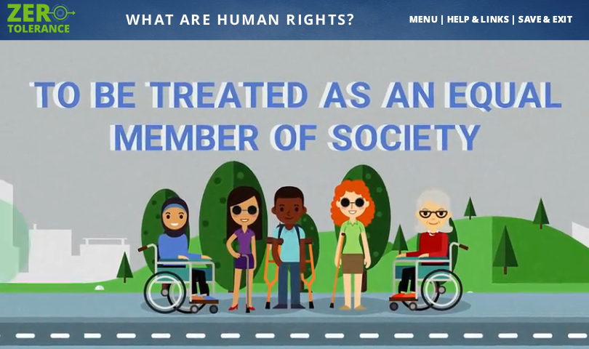
Link: Human Rights and You Animations

Slide 5

Zero Tolerance to abuse
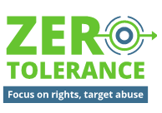
- Understanding Abuse
- Promote and apply human rights
- Understand causes of abuse
- Recognise risk factors and signs of abuse
- Practices and Safeguards which can help prevent abuse
- Implement policy and practice that protect people’s rights
- Support empowerment of people with disability
- Create the right organisational cultures
- Addressing Risk for Specific Groups and Service Settings
- Targeted approaches for groups at increased risk of abuse
- Targeted service features and settings that increase risk
- Reducing and eliminating restrictive practices
- Responding to abuse
- Early intervention and response
- Supporting the person
- Meet legal and organisational requirements
- Analysis, Learning and Improvement
- Maintain and analyse records
- Continuous improvement
- Support initiatives to reduce abuse
Link: NDS Zero Tolerance Website

Slide 6

Focusing on the quality of life
- Emotional (how I feel)
- Relationships (the people in my life)
- Education (things I’ve learned and things I want to learn)
- Economic (my job and my money)
- Physical (my health and my body)
- Social (my life in my community)
- Identity (who I am and what I believe)
- Material (my home and my things)

Slide 7

The NDS Empowerment circle
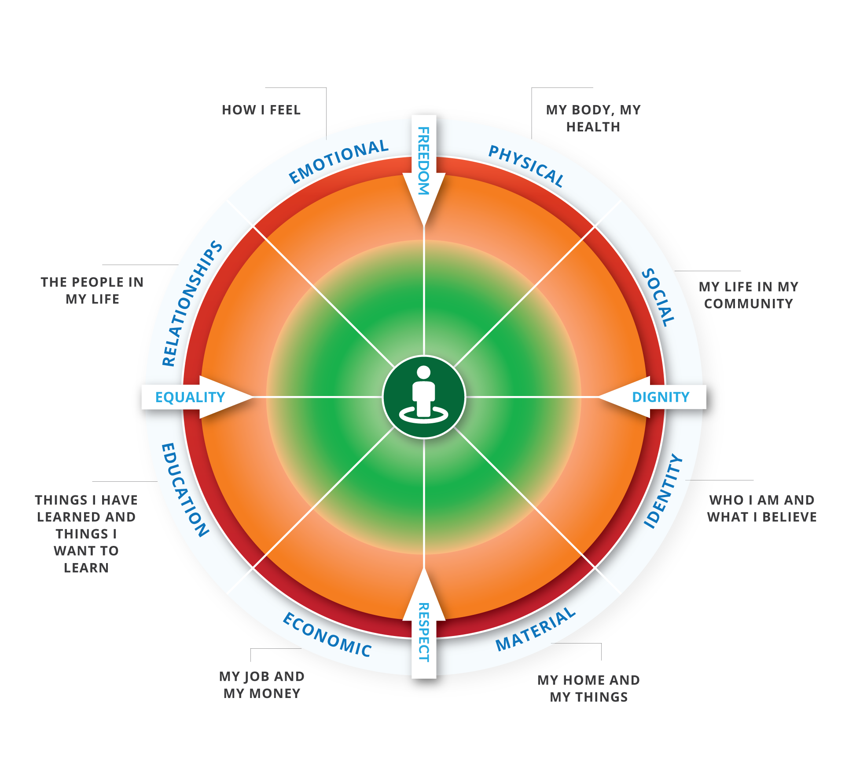
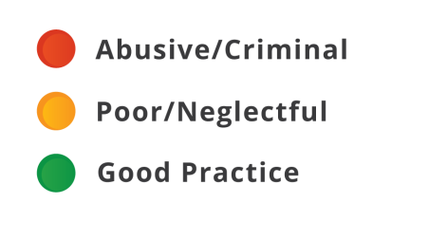
NDS Empowerment circle

Slide 8

What are restrictive practices?
- “any practice or intervention that has the effect of restricting the rights or freedom of movement of a person with disability, with the primary purpose of protecting the person or others from harm.”
National Framework for Reducing and Eliminating the Use of Restrictive Practices

Slide 9

NDS Recognising Restrictive Practices Films

Seven pairs of films:
- Physical restraint
- Chemical restraint
- Mechanical restraint
- Seclusion
- Restricted access
- Power control
- Consequence control
Link: NDS Recognising Restrictive Practices Films
Decorative image omitted.

Slide 10

Physical restraint film
Link: Physical Restraint Video

Slide 11

Physical restraint reflections
Link: Physical Restraint Video Reflections

Slide 12

The misuse of restrictive practices
- Restrictive Practices can be overused or misused
- Sometimes staff may not even be aware that they’re implementing a restrictive practice
- Staff training, supervision and reflective practice is critical
- Identify when there is a higher risk and implement strategies to minimise this
- Encourage new staff to question restrictive practices are in place
- Foster a positive organisational culture to ensure people feel safe to speak up
Link: NDS Positive Cultures Films

Slide 13

What does the evidence tell us?
- Restrictive practices have a negative impact on the wellbeing and quality of life of people with disability (Sigafoos, Arthur, O’Reily, 2003; Singh, Lloyd, Kendall, 1990).
- High quality behaviour support plans lead to a reduction in restrictive practices over time. Lower quality plans lead to an increase in restrictive practices (Webber, L., Richardson, B., Lambrick, F., Fester, T. 2012).
- Strong leadership, workforce development and the use of debriefing following the application of restrictive interventions can reduce the of use of restrictive practices (LeBel et al, 2012).

Slide 14

Capable environments
- Positive social interactions
- Support for communication
- Support for participation in meaningful activity
- Provision of consistent and predictable environments, personalised routines, and activities
- Support to establish and/or maintain relationships with family and friends

Slide 15

Capable environments
- Provision of opportunities for choice
- Encouragement of more independent functioning
- Personal care and health support
  - Link: CID Health Fact Sheets
- Provision of acceptable physical environments
- Mindful, skilled support workers and carers.
McGill, P., Bradshaw, J., Smyth, G., Hurman, M., & Roy, A. (2014).

Slide 16

Practice Leadership
- “An individual who develops, encourages and supports their staff team to put into practice the vision of the organisation.” (Beadle-Brown, Bigby, Bould, 2015)
- Encouraging people to focus on continuous improvement
- Empowering and inspiring support workers
- Supporting the implementation of positive behaviour support
- Facilitating reflective practice

Slide 17

Reflective Practice
Gibbs G, (1998).
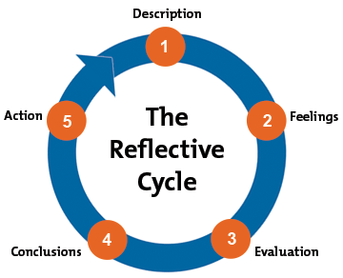

Slide 18

References
Beadle‐Brown, J., Bigby, C., & Bould, E. (2015). Observing practice leadership in intellectual and developmental disability services. Journal of Intellectual Disability Research,59(12), 1081-1093.
Chan, J., French, P., & Webber, L. (2011). Positive behavioural support and the UNCRPD.International Journal of Positive Behavioural Support,1(1), 7-13.
Gibbs, G. (1988). Learning by doing: A guide to teaching and learning methods.Further Education Unit.
LeBel, J, Nunno, MA, Mohr, WK and O’Halloran, R (2012), Restraint and seclusion use in U.S. school settings: Recommendations from allied treatment disciplines, American Journal of Orthopsychiatry, vol. 82, no. 1, pp. 75–86.
Mansell, J., Beadle-Brown, J., Ashman, B., & Ockenden, J. (2004). Person-centred active support: A multi-media training resource for staff to enable participation, inclusion and choice for people with learning disabilities. Brighton, UK: Pavilion.
McGill, P., Bradshaw, J., Smyth, G., Hurman, M., & Roy, A. (2014). Capable environments. Chapter in: Banks, R. & Bush, A.(eds) Challenging Behaviour: A Unified Approach.
Schalock, R. (2004). The concept of quality of life: what we know and do not know. Journal of Intellectual Disability Research. 48:3,203-216
Webber, L., Richardson, B., Lambrick, F., & Fester, T. (2012). The impact of the quality of behaviour support plans on the use of restraint and seclusion in disability services. International Journal of Positive Behavioural Support, 2(2), 3-11.
End of document

