National Disability Services

Slide 1

Practice Leadership Workshop for Behaviour Support Practitioners

Collecting Meaningful Data and Measuring Outcomes
Facilitator: David Wragg
Slide 2
Acknowledgement
We acknowledge the traditional people of Australia and pay respect to elders past, present, and emerging.

Slide 3

Housekeeping and Disclaimers
- Please step out and attempt to minimise disruption if you need to take a call.
- Feel free to join in and discuss topics, but please depersonalise any information you use.
- The usual conduct around confidentiality of individuals’ personal information applies.
- The content of this workshop is designed to be applicable to a wide range of PBS practitioners and professionals.
- This workshop is intended to give participants direction for their own practice, but nobody will be an expert in data collection at the end of the day.

Slide 4
Workshop series
Practice Leadership Workshops for Behaviour Support Practitioners
- Implementing positive behaviour support
- Reflective Practice
- Collecting meaningful data and measuring outcomes
- Supporting the person (and their support network) to be involved in the development of their own plan.

Slide 5
About us
Guidestar provides services in
- Positive behaviour support and training for professionals
- Support coordination
- Psychology services
- Organisational and professional support.

Slide 6

Outcomes of today’s discussion
- Improve our understanding of data as it relates to the capability framework
- Gather new ideas on how to use data to inform services and report outcomes
- Discuss quality of life improvements as a performance metric
- Share successes and barriers regarding data collection.

Slide 7

COVID-19
The content of this program was developed to be an in-person workshop prior to the COVID-19 outbreak.
Given the change of circumstances, it is anticipated that the conversation may include practitioner challenges and ideas to address the current situation.
While no slides have been prepared for COVID-19, please feel free to discuss the topic in the context of current events.

Slide 8

Applied Behaviour Analysis compared with Positive Behaviour Support

Slide 9

Applied Behaviour Analysis (ABA)
ABA is concerned with the study of socially significant behaviour under natural circumstances.
Applied: Addressing problems to improve people’s life
Behavioural: Focused on observable, clearly defined, and measurable events rather than verbal reports or other methods
Analytical: Reliably demonstrating cause-and-effect between behaviour and events
Technological: Clearly describing techniques to ensure reproducibility
Conceptually Systematic: Focus on basic behavioural principles such as reinforcement and stimulus control
Effective: Interventions are judged on social importance of change, not just behaviour
Generality: Behavioural change endures across people and settings
(Weiss, DelPizzo-Cheng, LaRue, & Sloman, 2010).

Slide 10

Positive Behaviour Support (PBS)
An applied science that uses educational methods to expand an individual’s behaviour repertoire and systems change methods to redesign an individual’s living environment to first enhance the individual’s quality of life and, second, to minimise his or her problem behaviour.
(Carr et al. 2002, p. 4)

Slide 11

PBS is based on the values and principles of:
- Inclusion
- Person Centred Values
- Comprehensive Lifestyle Changes
- Lifespan Perspective
- Ecological Validity
- Stakeholder Participation
- Social Validity
- System Change and Multicomponent Intervention
- Emphasis on prevention
- Flexibility with Respect to Scientific Practices
- Multiple Theoretical Perspectives.

Slide 12

Positive Behaviour Support
PBS emerged from:
- Applied Behaviour Analysis
With respect to concepts, PBS is indebted to applied behaviour analysis for the notion of the three-term contingency, the concepts of setting event and establishing operations, and the notions of stimulus control. (Carr, 2002, p. 3).
- The Normalisation/Inclusion movement
  - People with disabilities should have access to the same opportunities as others
  - Be included within mainstream society
  - Entitled to their Human Rights.

Slide 13

Positive Behaviour Support
- Social Roles
  - Creating, maintaining and protecting social roles
- Person Centred Values
  - Person Centred Planning: What do I want?
  - Making their own decisions.

Slide 14

Thoughts so far

Slide 15

Levels of measurement
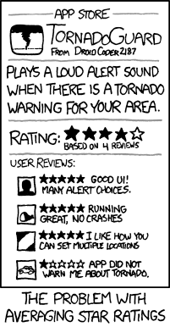

Slide 16

Levels of measurement
Nominal Data: Names or categorizes something
- Examples: Names, diagnoses, days of the week
Ordinal Data: Used for ranking relative to one another, no information on distance between values
- Examples: Rankings, Likert scales
Interval Data: Steps between intervals are equal, but no meaningful ‘0’
- Examples: Time of day, years, temperature, IQ
Ratio Data: Has equal intervals and a meaningful ‘0’
- Examples: Elapsed time, number of clients, frequency of a behavior.
(Hanna & Dempster, 2012), (Field, 2013)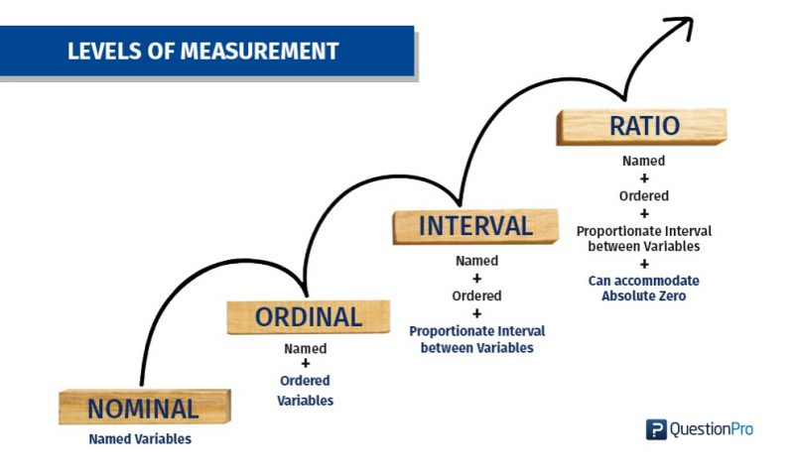
Nominal, Ordinal, Interval, Ratio Scales with examples

Slide 17
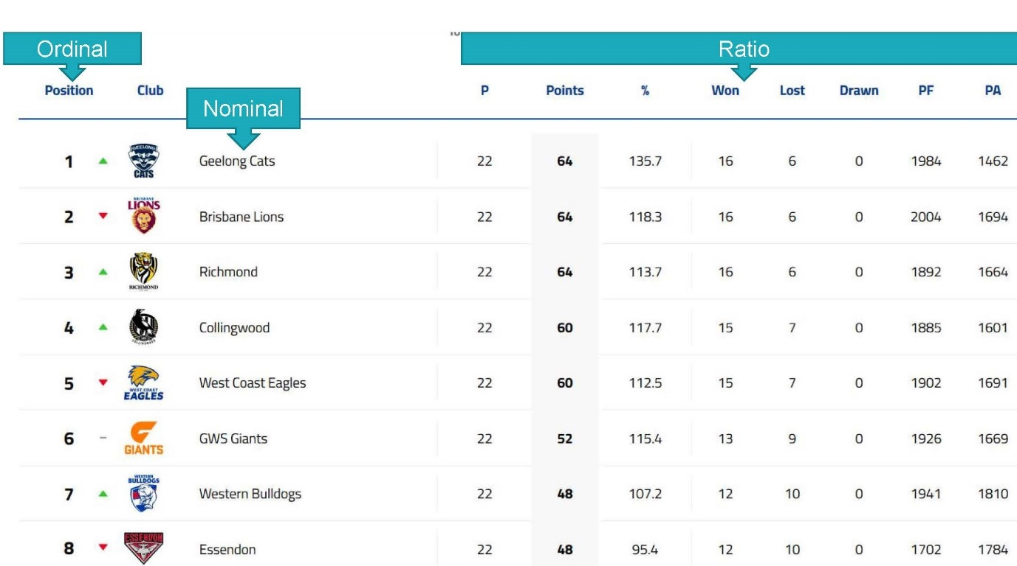

Slide 18

Measures of Central Tendency (Averages)

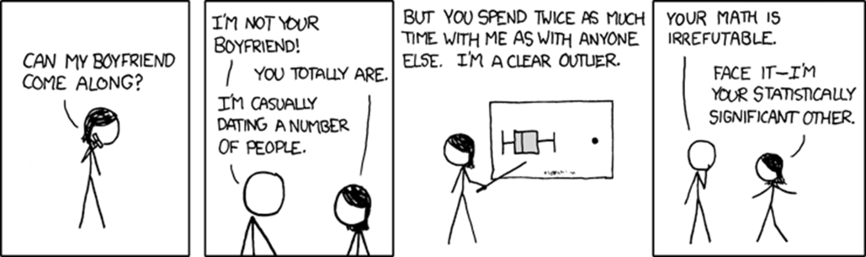

Slide 19

Types of Averages

Mean
- Affected by outliers but can give more nuanced information. Cannot be used with ordinal or nominal data (the average of blue and yellow ≠ green)

Median
- Not affected by extremes, gives the middle value, but not as nuanced. Harder to use with large groups of ratio data. Can use with ordinal and interval data

Mode
- Most frequently occurring value in a data set, can be used with any level of interval.

Slide 20

Types of Averages

Mean
Calculated by taking the sum of a data set and dividing by number of points in the data set

Benefits:
- Can give more nuanced or detailed results
- The type of arithmetic that can be done is much greater

Drawbacks:
- Affected by extreme values and outliers; a single extreme value can alter the mean drastically
- Can only be used with interval/ratio data
  - You can’t divide an aggression by an absconding?
  - You can’t divide “sometimes” by “all the time”?
  - What is the average of yellow and blue (please don’t say green).

Slide 21

Types of Averages (cont.)

Median
- Calculated by taking all data points and finding the one that falls in the middle
- In a data set of: 1,1,1,2,3,3,4,4,4,4,4,4,5 (med= 4)
  - In the case of two medians, average two middle values

Benefits:
- Not affected by outliers or extreme values
- Can be used with Ordinal Data as well as Int/Ratio data
- Useful to visualize values (in data above, 4 and 1 happen quite often)
- Can help to eliminate ‘noise’ in data

Drawbacks:
- Cannot do complex arithmetic or combine with the mean of a data set
- Does not give as much detail when used with Int/Ratio data.

Slide 22

Types of Averages (cont.)

Mode
The most frequently repeated value in a dataset

Benefits:
- The only average that can be used with Nominal Data
- Easy and fast to identify

Drawbacks:
- Can only be used with interval/ratio data
  - You can’t divide an aggression by an absconding
  - You can’t divide “sometimes” by “all the time”
- May have multi-modal data
  - A dataset can’t have no mode, only 1 or more mode. Therefore data is said to be bimodal, trimodal, etc.

Slide 23

Why do we collect data?
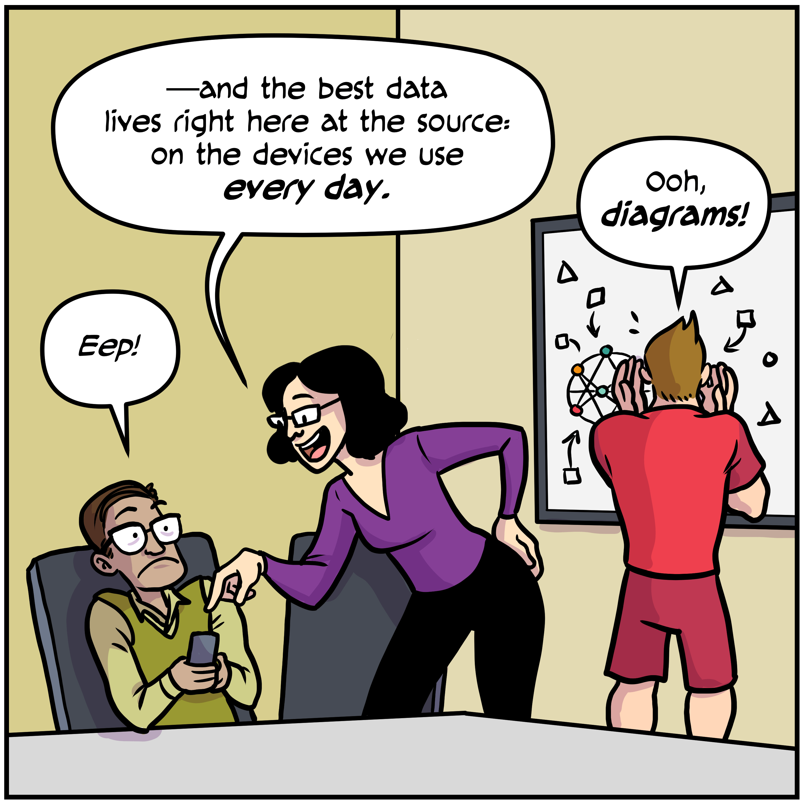

Slide 24

Why do we collect data?
- Understand or describe a situation
- Find correlations between variables
- Test hypotheses
- Measure changes in behaviour and quality of life
- To meet capability framework criteria.

Slide 25

Capability Framework and Data
Interim Response
- Evaluate the risk posed by the behaviour to the person (i.e. How frequent or intense is the behaviour? How long does it last?)
- Record and report accurately
Begin by establishing a baseline for the behaviour.
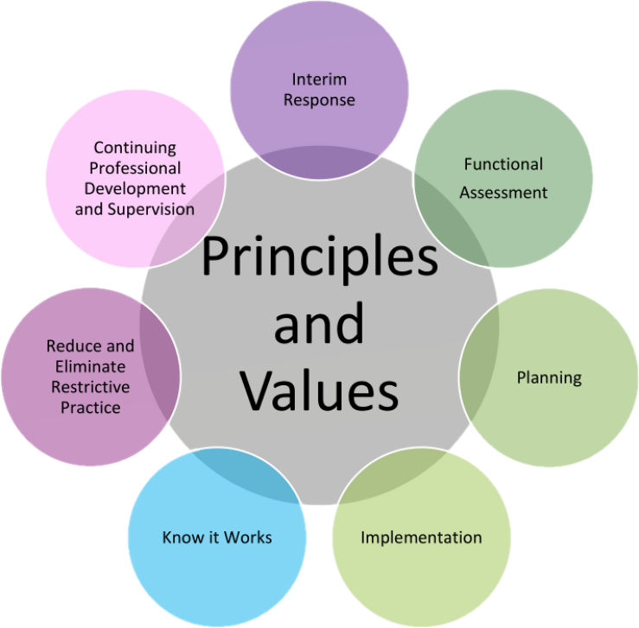

Slide 26

Establishing a baseline
Start with an operational definition:
“In an operational definition, a behavior is explicitly or clearly defined such that it is measurable, can be identified by two or more observers, and can be identified across time and in different settings or contexts.” (Bicard & Bicard, 2012, p.12)
We can’t begin to measure a behaviour accurately across settings unless we can agree on what is being measured, these concepts are known as validity and reliability.

Slide 27

Establishing a baseline
By having a clear idea of what we are recording, we can then take data on the:
- Frequency: Counting how often something occurs
- Intensity: Often measured using a Likert scale
- Duration: How long a behaviour occurs
For example:
Self-injury presents approximately 4 times per week with an average duration of 12 minutes with a range of 2 minutes to 33 minutes. The impact of this behaviour ranges from red marks on the arm to injuries requiring attention from paramedics. On average paramedics are called every 9 months to attend to injuries resulting from self-injury.

Slide 28

Likert scales as intensity measurements
- A Likert Scale can be used to rank behaviour and provide an intensity scale.
- Data collectors may rate a behaviour differently if no guidelines are given.
- Creating a rubric can be useful to increase reliability.
Example:
Self Injury Rubric
- Red marks on the skin.
- Results in minor abrasion/laceration/bruising
- Results in abrasion/laceration that requires application of a plaster or bandage
- Results in significant bleeding
- Presence of emergency services or professional medical attention.

Slide 29

Interim Response and Data
Establishing a baseline not only helps as a basis of comparison.
The process can help to assess risk, prioritise goals, and understand how the behaviours of concern are impacting on quality of life.

Slide 30

Capability Framework and Data
Functional Assessment
- Understand the importance of obtaining baseline measures of behaviours of concern, quality of life, and use of restrictive practices
- Understand the importance of data driven decision making
- Systems to collect data from a variety of sources
- Identify antecedents and maintaining consequences
(Table of Principles and Values with seven smaller circles is repeated here from Slide 25).

Slide 31

Using data to conduct a functional assessment
- What data or tools can we use to assist in conducting a functional assessment?
- Having detailed and frequent data can help to establish a function.

Slide 32

Using data to conduct a functional assessment
What happens if we don’t have data? What can we do?
- Discuss or conduct observations with stakeholders
- Conduct a file review of session notes/IRs/health notes/etc.
- Use assessment tools such as the Questions about behavioural function, Behaviour Problem Inventory, Functional Assessment Interview, etc.
- NDIS Compendium of Resources.

Slide 33

Capability Framework and Data
Planning:
- Use data to inform a theoretical and ethically sound behaviour support plan
- Develop strategies to improve a person’s quality of life.
- Develop strategies to increase the person’s skills and communication
- Develop data collection systems that are objective, understandable, and useable by the key people.
- Develop a behaviour support plan that is supported by data that measures how accurately it is implemented.
(Table of Principles and Values with seven smaller circles is repeated here from Slide 25).

Slide 34

Operationalising Person Centred Goals
Person-Centred Planning
“Person-centred planning begins when people decide to listen carefully, and in ways that can strengthen the voice of people who have been, or are at risk, of being silenced” (O’Brien, as cited in Sanderson, p. 304)
Key features of a person-centred plan:
- The person is at the centre, with the plan emphasising their voice.
- Families and friends are partners in planning.
- Reflects a person’s wishes, aspirations and capacities, rather than needs and deficits
- Includes life goals, not goals centred around services. These should reflect what’s possible, not just be limited to what’s available or what services can manage to achieve
- Includes a shared commitment to action and involves ongoing listening and further actions to help a person achieve what they want for their life.

Slide 35

Operationalising Person Centred Goals
Often NDIS goals are person centred, achievable, relevant, but vague.
“Mark wants support to access the community, learn new skills, and learn to better manage his emotions”.

Slide 36

Operationalising Person Centred Goals
“Mark wants support to access the community, learn new skills, and learn to better manage his emotions”
- “Mark went out every week” vs. “In February Mark accessed the community 14 times, 7 of these visits were to the Boar’s Head Hotel for Morning Melodies. The average duration of community access shifts was 175 minutes”
What other things could we record?
What questions can we ask about the accuracy of the measurement?

Slide 37

Operationalising Person Centred Goals
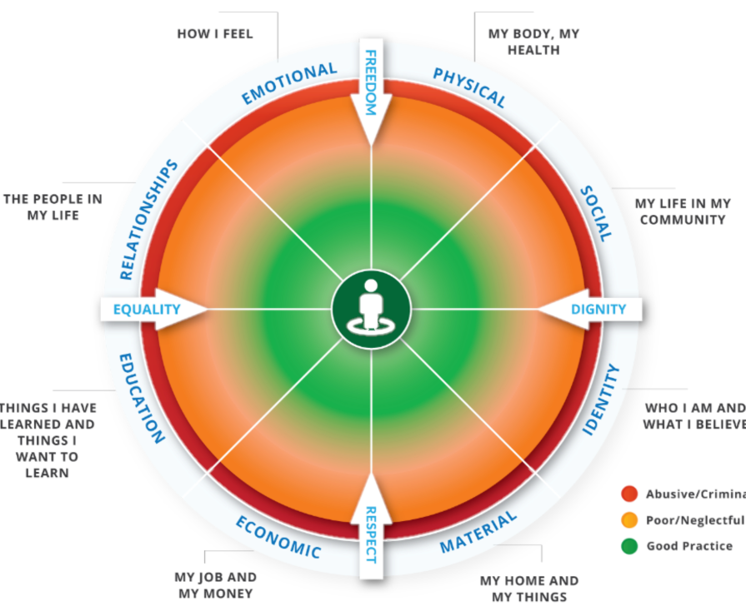
Empowerment circle

Slide 38

Operationalising Person Centred Goals
- Mood and wellbeing scales (QOLI, Depression inventories, etc.)
- Health outcomes (Physical stats, number of days in hospital, length of hospital stays)
- Community life (Number of friends, days in the community, membership in community groups)
- Identity (Attendance at religious/cultural events, time spent with people of the same background, number of friends who speak the same LOTE, etc.)
- Material (Adequate accommodation, equipment in good repair, have items of importance to them)
- Economic (Person is working as much as they’d like, enough money to meet needs/achieve goals, accounts not in arrears)
- Education (Attendance/Completion of courses, marks in classes, hours for L’s/P’s)
- Relationships (Friendships, Romance, Social skills education).

Slide 39

Operationalising Person Centred Goals
In data analysis and behaviour support there is a tendency to focus on behaviours of concern.
This can mean a practitioner’s success, or plan’s efficacy, may only be measured by a reduction in the frequency, duration, and/or intensity of behaviours of concern.
This can lead to someone who is “easy” or docile being one of the ‘success stories’.

Slide 40

Capability Framework and Data
Implementation
- Identify appropriate methods of feedback for those implementing a behaviour support plan
- Support those implementing a behaviour support plan to use the recommended data collection systems
- Support implementation across different environments and contexts
(Table of Principles and Values with seven smaller circles is repeated here from Slide 25).

Slide 41

Implementation
Individuals often have different providers which can make it hard to make an apples-to-apples comparison.
Having inconsistent data collection can also introduce a bias.
“Carrie attends Elder Anne day program who requested behaviour support due to the fact that they are submitting upwards of 6 incident reports per day. While conducting initial discussions with the house supervisor at 4 Yavin Road (her accom provider), their data recordings indicate behaviour presents at a rate of roughly 1.5 times per day but no incident reports have been submitted in 6 months”.

Slide 42

Reliability and Validity
- Reliability: “Reliability in functional assessment refers to agreement among observers viewing the same behavior at the same time regarding its occurrence or non-occurrence.” (Gresham, Watson & Skinner, 2001, p.169)
- Validity: The extent to which a measure relates to the information being sought. (Price, Jhangiani R., & Chiang, 2015)

Slide 43

Capability Framework and Data
Know it works
- Use data to monitor implementation of behaviour support plans in a whole-of-life context
- Track progress of a behaviour support plan using indicators of effectiveness
- Understand systematic monitoring and evaluation
- Have robust and effective ways to measure and evaluate outcomes
- Use data to explain the reason(s) behind a behaviour support plan’s effectiveness
- Apply and interpret measures that capture an increase in behaviours or use of RPs, or decrease in QoL.
(Table of Principles and Values with seven smaller circles is repeated here from Slide 25).

Slide 44

Are we achieving the goals we have set?
To determine this, it helps to take data continuously; this allows us to determine if there has been a reduction in behaviour or if reductions have been maintained.
Often, we’re not recording the data we want- times when no behaviour is occurring!

Slide 45

Are we achieving the goals we have set?
What sort of data can we collect to see to assess the effectiveness in interventions?
- Frequency of behaviour
- Intensity of behaviour
- Duration of behaviour (where applicable)
- How often is someone using replacement behaviour (opportunity data)
- Quality of life measures (e.g. Quality of life inventory, pleasant events Schedule, Health of the nation outcomes survey, frequency of quality of life increasing events, duration of quality of life increasing events, health indicators, etc.)
- Evidence of increased skill (Task analyses are particularly useful here).

Slide 46

Capability Framework and Data
Reduce and Eliminate restrictive practices
- Understand that restrictive practices must be justified and are an option of last resort
- Restrictive practices can only occur when a behaviour support plan is in place
- Ensure behaviour support plan is outcomes-focussed, person-centred, and strategies proactively address a person’s needs
(Table of Principles and Values with seven smaller circles is repeated here from Slide 25).

Slide 47

Data collection practices and restrictive practices
- What sort of information might a medical practitioner need to reduce Restrictive Practices?
- How can we use data to plan out and reduce restrictive practices?
- What sort of data collection or analysis do we use in our own practice to plan a reduction in Restrictive Practices?

Slide 48

Slide 48

Capability Framework and Data
Continuing professional development and supervision
- Conduct regular professional development plans
- Participate in supervision
- Evaluate supervision
When investigating new techniques or modalities, consider the concepts of validity and reliability.
(Table of Principles and Values with seven smaller circles is repeated here from Slide 25).

Slide 49

Barriers to Data Collection
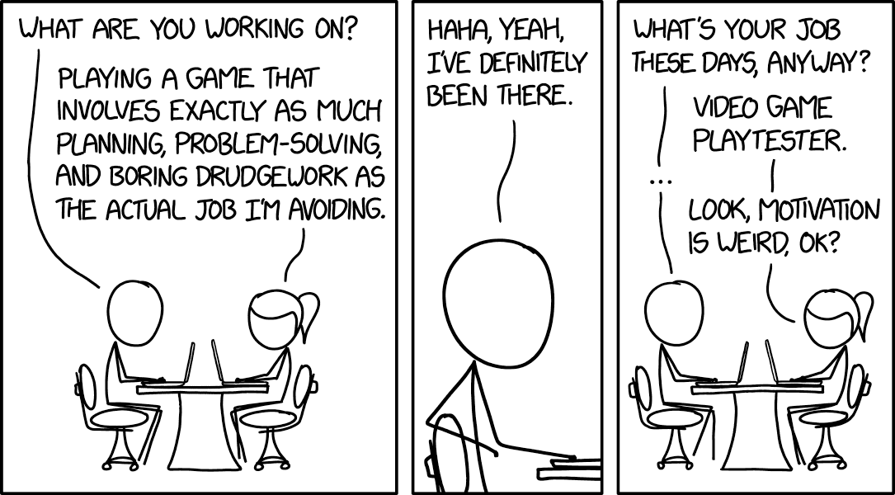

Slide 50

Discussion
- How does data collection usually go for us?
- What is the quality of the data we receive? Is it usable?
- What do we currently do to facilitate data collection?
- What feedback do we get from staff when we ask for data?
  - Not enough time
  - Too confusing
  - Already collecting data
  - What’s the point?

Slide 51

Sample data
Scenario:
In September 2019 Hayden, a man in his 20’s, encountered several significant life events. Within the span of a few weeks he missed out on a significant promotion, separated from his wife, had a falling out with his best friend and mentor, and suffered significant injuries that required significant medical intervention. Around this time Hayden began engaging in several behaviours of concern including harm to self, harm to others, property damage, verbal aggression, and “unusual” but non-harmful behaviour such as acting in a grandiose manner and dressing in all black.
After his recovery he began associating with a manipulative and anti-social peer group. Although they were not a positive influence, Hayden found himself in a privileged position amongst this group.
In January 2020 Hayden engaged with services, and his team began collecting data on behaviours of concern and wellbeing indicators. Given the complexity of the circumstances, staff indicated they were unable to collect data on all behaviours of concern.

Slide 52

Sample data
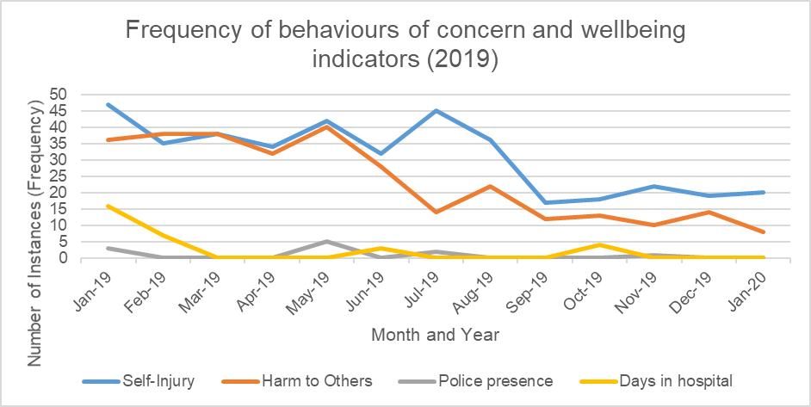
Jan-19
Self-Injury 47
Harm to Others 36
Police presence 3
Days in hospital 16
Feb-19
Self-Injury 35
Harm to Others 38
Police presence 0
Days in hospital 7
Mar-19
Self-Injury 38
Harm to Others 38
Police presence 0
Days in hospital 0
Apr-19
Self-Injury 34
Harm to Others 32
Police presence 0
Days in hospital 0
May-19
Self-Injury 42
Harm to Others 40
Police presence 5
Days in hospital 0
Jun-19
Self-Injury 32
Harm to Others 28
Police presence 0
Days in hospital 3
Jul-19
Self-Injury 45
Harm to Others 14
Police presence 2
Days in hospital 0
Aug-19
Self-Injury 36
Harm to Others 22
Police presence 0
Days in hospital 0
Sep-19
Self-Injury 17
Harm to Others 12
Police presence 0
Days in hospital 0
Oct-19
Self-Injury 18
Harm to Others 13
Police presence 0
Days in hospital 4
Nov-19
Self-Injury 22
Harm to Others 10
Police presence 1
Days in hospital 0
Dec-19
Self-Injury 19
Harm to Others 14
Police presence 0
Days in hospital 0
Jan-20
Self-Injury 20
Harm to Others 8
Police presence 0
Days in hospital 0

Slide 53

What’s the point?
Imagine that, at the August 2019 staff meeting the general consensus is that “Things are getting worse”. What is the data telling us? How can we empower staff?

Slide 54

What’s the point?
- Other examples where having ready access to data can be useful?
  - Reporting to statutory and/or funding bodies such as NDIS, Dept. of Justice, etc.
  - Assessing efficacy of interventions (including medication)
  - Provide encouragement to staff or the person we are serving
  - Quantifying data can provide a more objective outlook on all of the above.
Since engaging with services, Christian has spent 14 days in hospital compared with 16 days when the baseline was taken. Total police contact has occurred and averages .84 contacts per month (range 0 to 5 contacts per month); police contact occurs approximately every 2-3 months. Additionally, Self-injury occurred 29.83 times per month on average between Feb 2019 and Jan 2020 (range 17 to 45) compared to a baseline recording of 47.

Slide 55

It’s too hard/confusing
- Staff may not have the same numeracy skills as a practitioner and may find the process overwhelming when it is presented to them.
- Staff have several tasks to complete throughout the day and may see data collection as an additional task then distracts from other duties (especially keeping people safe and providing care).
- Data collection tools may be too complex, unwieldy, (STAR data, for instance) or instructions may be unclear.
- There may be too many data collection tools.
Remember: Confusing data collection can introduce bias.

Slide 56

It’s too hard/confusing
How do we mitigate resistance to data collection?
- Explain the rationale for data collection
- Understand staff role and tailor data sheets accordingly
- Use providers’ existing data collection, where possible
- Nominate a specific person to have oversight of data collection
- Provide regular feedback with data sheets; staff generally respond positively to having a monthly or quarterly data summary
- Provide coaching and example data sheets
- Be specific in what we need.

Slide 57

It’s too hard/confusing
Decorative image omitted.

Slide 58

We’re already collecting data
Consider the following:
How quantifiable is the data?
- “Went to the park, minimal BoCs” vs. “Went to Handy Reserve from approx. 10:30am – 12:30pm. 2x instances of self-injury, both occurred when passing couple who appeared to be in their 70’s, walking a small dog.”
  - Is what is being recorded useful?
  - Are we collecting too much, or too little data?
  - Is the data generalisable?
Where possible, try to leverage the existing data collection (e.g. Riskman, Session notes, etc.) and provide feedback on what can make them more usable.

Slide 59

Data Collection Methods
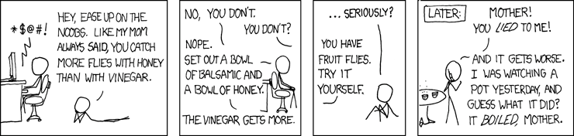

Slide 60

Baselines for behavior including frequency, duration and intensity
Frequency is the number of times a behavior occurs. Frequency of behavior can be measured for behaviors that have a beginning and an end (i.e. are discreet). Frequency of behavior is often converted to a rate of behavior by dividing the frequency of behavior by time observed (e.g. in minutes) in ‘event-based recording.’ (Gresham, Watson & Skinner, 2001).
- Can be difficult to capture each instance of a behaviour, and interval recordings can introduce bias into data collection
- Typically used for BoCs, but can be used for fluency in a skill or to record positive behaviours (though opportunity data is a better choice)
- Allows for more meaningful stats and can provide more resolution in data.

Slide 61

Baselines for behavior including frequency, duration and intensity
Duration refers to how long a behavior lasts and can be measured in seconds, minutes or hours. (Gresham, Watson & Skinner, 2001, p.164).
- Uses ratio data: allows for more meaningful stats
- Again, typically used for behaviours of concern but can also be used for positive behaviour such as attention to a task, time between incidents, etc
- Generally requires some sort of time keeping, particularly in high-stress situations.

Slide 62

Baselines for behavior including frequency, duration and intensity
Intensity is “A description of the heightened impact of the behavior, e.g., the depth, the force, the strength, the vigor or extreme level of the behavior.” (Wright, Cafferata, Keller & Saren, 2013, Section 4 p. 9).
How can we measure intensity?
- Likert scales (requires a pre-set scale, ordinal data limits stats that can be derived)
- Financial costs associated with behaviour
- Level of charge associated with behaviour: this is most appropriate for forensic settings as it may be unnecessarily stigmatising to a person outside of the forensic setting
- Duration can also be an intensity measure
- Impact on self/others.

Slide 63

Interval recording
- Interval recording: “measures record behavior as occurring or not occurring during specified time intervals.” (Gresham, Watson, & Skinner, 2001, p. 163-164)
- Partial interval recording: “a target behavior is recorded if it occurs at any time during the interval.” (Gresham, Watson, & Skinner, 2001, p. 164)
- Whole interval recording: “a target behavior is recorded if it occurs for the entire interval.” (Gresham, Watson, & Skinner, 2001, p. 164)
  - Can be useful when frequency is too difficult to obtain (e.g. using partial interval with an interval of 24 hours)
  - Intervals can be tailored to the person but must be equal (e.g. 1 day or 12 hours is OK, but an interval of 1-shift is irregular)
  - Whole intervals can be used to increase positive behaviours with reinforcement (e.g. “Way to go! You worked for 30 minutes straight so we can take a longer break now!”).

Slide 64

Task Analysis
Task Analysis: “the process of breaking down a complex behavior into smaller parts or steps.” (Wolfe, Condo & Hardaway, 2009, p.54).
- Useful for data recording as it allows to show progress toward completing a complex task, rather than a binary correct/incorrect response
  - E.g. In January completed 2/12 steps of a T.A.; in February consistently completed 3/12 steps
- Useful for reinforcement or demonstrating progress in completing a task
- Can give insight as to which subskill needs to be prompted or taught
  - E.g. In a teeth brushing T.A., we know that Stephen can complete steps 1-4 independently, so we focus on teaching step 5 (applying toothpaste).

Slide 65

STAR Charts/ABC Recording
STAR Charts. A model for understanding and alleviating emotional problems comprising of settings, triggers, actions and results. (Zarkowska & Clements, 1994, p. 8-12).
- Can provide detailed information, especially relating to contingencies between stimuli and behaviours
- Difficult to complete regularly
- Can be highly subjective and more prone to the writer’s bias
- A skilled note taker can complete STAR or ABC data that combines quantitative and qualitative data.

Slide 66

Collecting Data and Controlling for Bias
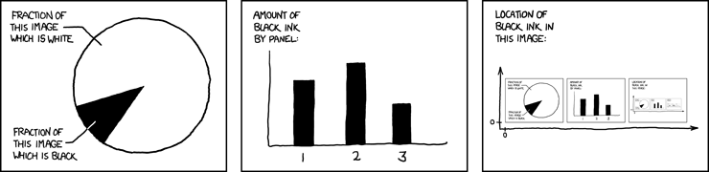

Slide 67

Considerations when collecting data
- Following a person around to collect data can be dehumanising or embarrassing for a person- particularly in the community
- Contriving situations to collect data can introduce bias or reduce social or ecological validity
How do we ethically collect data?

Slide 68

Considerations when collecting data
What can we do?
- Discuss data collection with the person and/or stakeholders and get guidance for how they would like this to occur
- Surreptitiously take data in the community- don’t follow the person around with a pen/clipboard and instead use a small slip of paper, write data on your hand, use a behaviour tracking app
- Limit how much data is taken at once, and identify the most relevant data
  - For example: At the grocery store track the use of social skills or shopping skills, not both
- Beware of introducing bias when choosing when/which type of data to collect.

Slide 69

Controlling For Bias
Factors that introduce bias:
- Measurement system such as number of variables being recorded
- Attributes of the observer such as level of training
- Setting where data is being recorded
- Consequences of scoring.
How can we control for these sources of bias?
- Limit how much data is being collected, or rotate what data is being collected
- Familiarise ourselves with potential sources of bias and controlling for them; share this knowledge with staff and design data collection accordingly
- Plan out how and when to collect data.

Slide 70

Controlling For Bias
Specific strategies for controlling for bias:
- Avoid collecting data at the same time, on the same day
- Rotate data collection duties amongst staff so that the same person is not always recording the same thing
- Record data in different settings, e.g. Grocery shopping might alternate data on social skills, behaviours of concern, task analyses, etc
- Ensure staff are trained to collect data in the same way so that interrater reliability is not affected
- Prioritise which behaviours and skills should be tracked; attempt to correlate behaviour with skills being taught.

Slide 71

Reporting data

Slide 72

Visualising Data: Line Graphs
- Useful for identifying relationships between multiple variables
- Useful for identifying trends across times
- Can show a linear cause and effect
- Independent Variable goes on x axis
- Dependent Variable goes on y axis
- Generally used to show linear/chronological relationships.

Slide 73

Visualising Data: Bar Charts

Slide 74

Visualising Data: Pie Charts

- Useful for looking at one variable across multiple categories
- Show how categories contribute to a whole
- Identify relative strengths or weaknesses.

Slide 75

Tables
- Adds credibility to analysis by providing raw data
- Succinct way to display complex or large data sets
- Breaks up “wall of text” in reports
- Easy to reference in your body
- Can combine bold/italics/underline to emphasize certain values.
Average frequency per day Feb 2017 – Nov 2017
Community
Aggression 4.83
Self Injury 5
Property Dmg 3.8
Accom
Aggression 4.5
Self Injury 5.5
Property Dmg 3.8
Day Program
Aggression 3
Self Injury 4.7
Property Dmg 4.9
Family Home
Aggression 3.8
Self Injury 6.2
Property Dmg 4.8
Work
Aggression 4.2
Self Injury 5.3
Property Dmg 4.3

Slide 76

Tips for discussing data
- Where possible, include a brief intro for each data set discussing:
  - What data was collected
  - How it was collected
  - What periods data was collected (e.g. from Dec 2 until Dec 23).
Concerns about data collection
- Only collected in one setting, period of collection was 6 months, but an entire month missing, etc
- Conscious/unconscious biases (“Narrative data indicates staff are recording thrown objects as both aggression and property destruction”).

Slide 77

Tips for discussing data
- Where necessary, identify your analysis methods (“The median value of December mood rankings indicates”)
- Tables and Charts will be numbered, making it easy to refer back to them in body text (e.g. Figure 2 shows) and ensures you don’t have to rewrite what’s in the figure/table
- As with the rest of the document, avoid speaking in the first person and act as though the data and figures are people speaking to you (e.g. “Table 1 shows”, “As shown in figure 3”, “When comparing averages”).

Slide 78

Thank you!
If you have any further queries, or would like to discuss other training available, you are welcome to contact me at:
David.wragg@guidestarlife.com.au
0456 000 364

Slide 79

Tools, templates and resources
Information on defining behaviour and collecting data
Data collection methods
Define behaviour
Data Collection Sheets
Earlywood tool
Data collection in autism
Data tracking
Integrity and reliability as quality indicators
Integrity and Reliability youtube
Data Collection types explained
Data collection types
Information on Task Analysis
Task Analysis youtube
Applied behaviour analysis

Slide 80

Tools, templates and resources
Google docs data tracking
Data tracking youtube
Music based discrete trial training
Music based youtube 1
Music based youtube 2
Music based youtube 3
Podcast on where to deliver services
Where can autism services take place soundcloud

Slide 81

Tools, templates and resources
Behaviour tracking apps (Android):
- ABC tracker
- Behaviour Observation Made Easy
- Behaviour tracker
Behaviour tracking apps (Apple)
- Behaviour tracker pro
- ABC Data Suite
- Behaviour Observation Made Easy

Slide 82

References
- Bicard, S. C, Bicard, D. F., & the IRIS Center. (2012). Defining behavior. Retrieved from The Iris Center Defining Behavior
- Bhat, A. (n.d). Ordinal data: definition, analysis and examples. Retrieved from Question Pro
- Carr, E. G., Dunlap, G., Horner, R. H., Koegel, R. L.,Fox, L. (2002). Positive behavior support: Evolution of an applied science. Journal of Positive Behavior Interventions, 4(1), 4.
- Carter, S. L., & Wheeler, J. J. (2019). The Social Validity Manual: Subjective Evaluation of Interventions. (2nd ed.). London, UK: Elsevier Inc.
- Corporate Finance Institute. (n.d.). Nominal Data. Retrieved from CFI Nominal Data
- Field, A. (2013). Discovering Statistics Using IBM SPSS Statistics. (4th ed.) [Kindle] Retrieved from Amazon.com.au.
- Formplus (2013). What is Interval Data? + [Examples, Variables & Analysis]. Retrieved from Formplus Interval Data

Slide 83

References
- Grandin, Temple (n.d.) Evaluating the Effects of Mediation. Retrieved from Indiana Resource Center for Autism on 09/02/2020
- Great Schools Partnership. (n.d.). The Glossary of Education Reform. Retrieved from Education Reform
- Gresham, F., Watson, T. S., & Skinner, C. H. (2001). Functional behavioral assessment: Principles, procedures, and future directions. School Psychology Review, 30, 156-172.
- Hanna, D. & Dempster, M. (2012). Psychology Statistics for Dummies. West Sussex, England.
- Kazdin A. E. (1977). Artifact Bias and Complexity of Assessment: The ABCs of Reliability. Journal of Applied Behavior Analysis, 10(1), 141-150. Retrieved from National Center for Biotechnology Information
- Klipfolio. (n.d.). What is Data Visualization? Retrieved from Klipfolio
- Lerman, D. C., Tetreault, A., Hovanetz, A., Bellaci, E., Miller, J. Karp H. Toupard A. (2010). Applying Signal-detection theory to the study of observer accuracy and bias in behavioral assessment. Journal of Applied Behavioral Analysis, 43(2), 195-213. Retrieved from National Center for Biotechnology Information

Slide 84

References
- Lumen. (n.d.). Introduction to Statistics: frequency, frequency tables and levels of measurement. Retrieved from Lumen
- Price, Paul C., Jhangiani R., & Chiang, I.A. (2015) Research Methods in Psychology retrieved on 07/02/2020 from BC Campus
- Repp, A. C., Nieminen, G. S., Olinger, E., & Brusca, R. (1988). Direct observation: Factors affecting the accuracy of observers. Exceptional Children, 55, 29–36.
- Trochim, William M.K. (2020) Research Methods Knowledge Base retrieved from Conjoint.ly on 07/02/20
- Shriver, M. D., Anderson, C. M., & Proctor, B. (2001). Evaluating the Validity of Functional Behaviour Assessment. School Psychology Review, 30 (2), 180-192.
- Weiss, Mary & DelPizzo-Cheng, Eliza & LaRue, Robert & Sloman, Kimberly. (2010). ABA and PBS: The Dangers in Creating Artificial Dichotomies in Behavioral Intervention. The Behavior Analyst Today. 10. 428-439. 10.1037/h0100681. Retrieved from APA PsycNet on 09/02/2020
- Wolfe, P.S., Condo, B., & Hardaway, E. (2009). Sociosexuality Education for Persons with Autism Spectrum Disorder Using Principles of Applied Behaviour Analysis. Teaching Exceptional Children, 42 (1), 50-61.

Slide 85

References
- Wolf, M. M. (1978). Social validity: The case for subjective measurement or how applied behavior analysis is finding its heart. Journal of Applied Behavior Analysis, 11 (2), 203-214.
- Wright, D. B., Cafferata, G., Keller, D., & Saren, D. (2013). The BIP Desk Reference: A Teacher and Behavior Intervention Team’s Guide to Developing and Evaluating Behavior Intervention Plans. Positive Environments, Network of Trainers, CA. Retrieved from Pent: Positive Environments, Network of Trainers
- Zarkowska, E., & Clements, J. (1994). Problem behavior and People with Severe Learning Disabilities: The STAR Approach (2nd ed.). London, UK: Chapman & Hall. DOI 10.1007/978-1-4899-7150-0
End of document.

